Task 2 – New Lead to Google Sheets
Google Forms → Google Sheets Automation

1. Objective
Automatically save every new lead submitted through the Google Form into Google Sheets using Zapier.

2. Trigger
App: Google Forms
Event: New Form Response
When a user submits the digital marketing enquiry form, Zapier receives the new response and passes the submitted information to the next step.

3. Action
App: Google Sheets
Event: Create Spreadsheet Row
The lead information is mapped to the corresponding columns in the Leads worksheet. Each new form submission is added as a new row automatically.

4. Test Result
The automation was tested successfully. Zapier created a new spreadsheet row containing the submitted lead's details, including name, email, phone number, service interest, budget, challenge, start timeline, and requirements.

5. Business Usefulness
This automation eliminates repetitive manual data entry and keeps all incoming leads organized in one Google Sheet. It helps the marketing or sales team access new enquiries quickly and maintain a consistent lead database.

6. Screenshots / Evidence
1. Zapier Workflow – Google Forms to Google Sheets
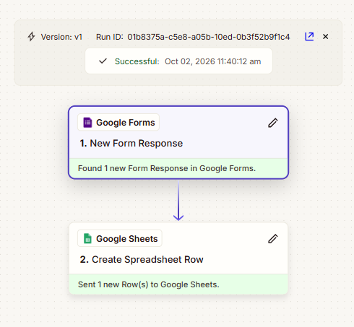
2. Successful Zapier Run – Create Spreadsheet Row
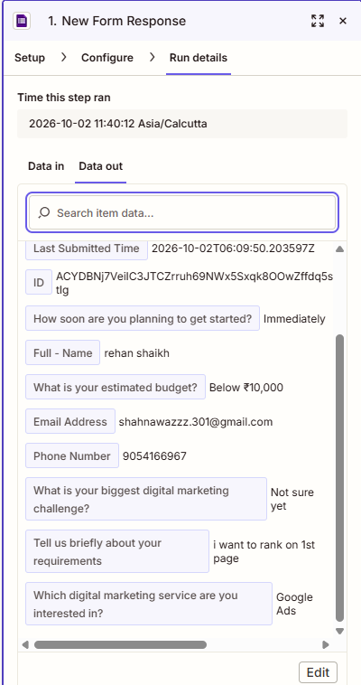
3. Google Sheets – New Lead Successfully Added
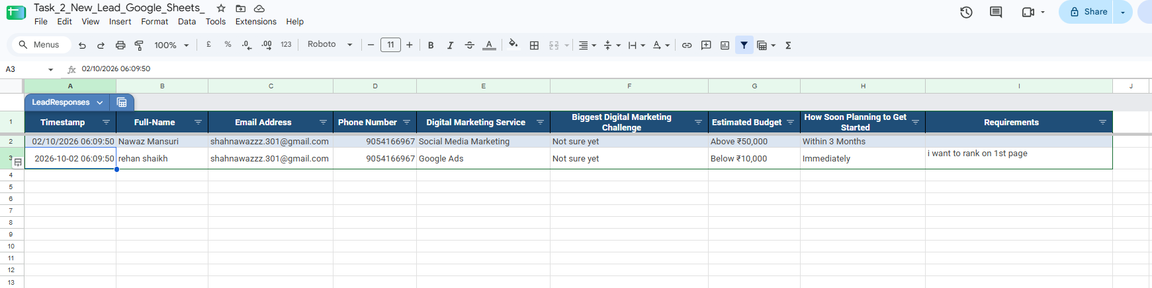
4. Zapier Task History – Successful Workflow
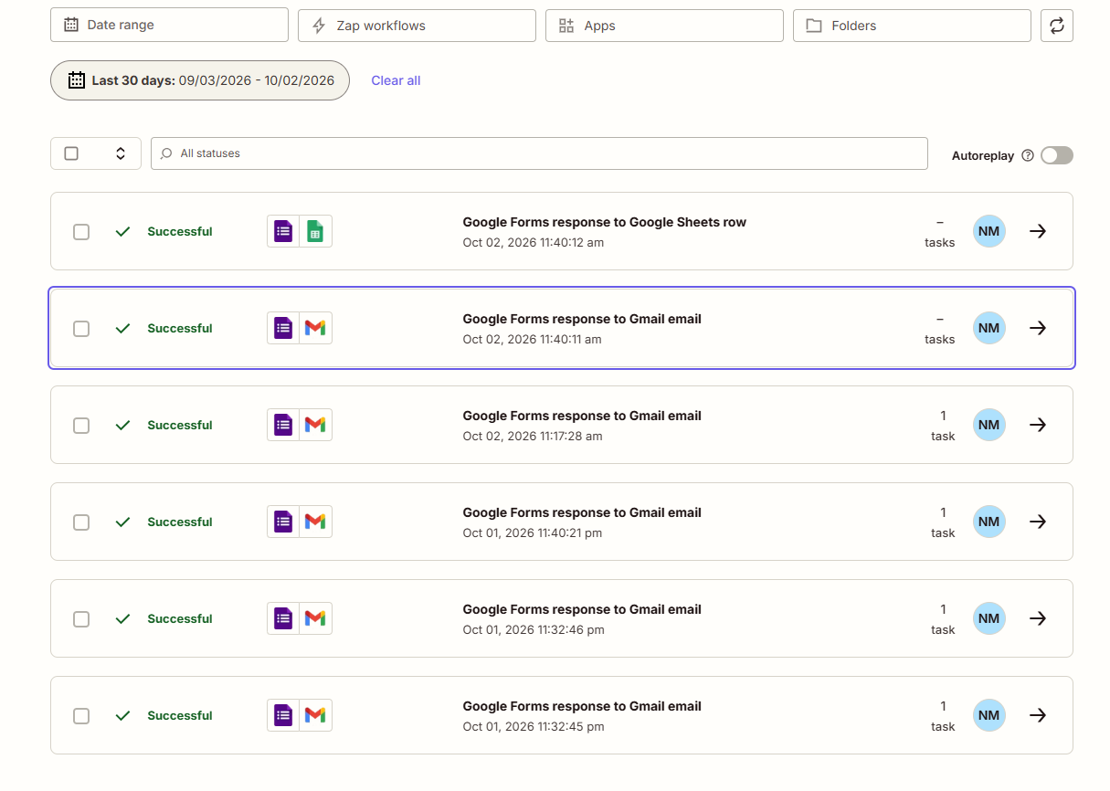

7. Submission Checklist
- Zapier workflow screenshot
- Trigger screenshot
- Action / test result screenshot
- Google Sheets result screenshot
- Business-use explanation

